**Day 7 Morning Assignments**

**By**

**Bhanu Prakash Reddy Chilukuri**

**NBHealthTech**

|  |
| --- |
| 1. Create Employee class with three variables and two methods |

**Code:**

internal class Employee

{

private int id;

private string name;

private int salary;

public void ReadEmployee()

{

Console.WriteLine("Enter id: ");

id = Convert.ToInt32(Console.ReadLine());

Console.WriteLine("Enter name: ");

name = (Console.ReadLine());

Console.WriteLine("Enter salary: ");

salary = Convert.ToInt32(Console.ReadLine());

}

public void PrintEmployee()

{

Console.WriteLine($"Id={id},Name={name},Salary={salary}");

}

}

internal class Program

{

static void Main(string[] args)

{

Employee employee1 = new Employee();

Employee employee2 = new Employee();

Employee employee3 = new Employee();

employee1.ReadEmployee();

employee1.PrintEmployee();

employee2.ReadEmployee();

employee2.PrintEmployee();

employee3.ReadEmployee();

employee3.PrintEmployee();

Console.ReadLine();

}

}

}

**Output:**

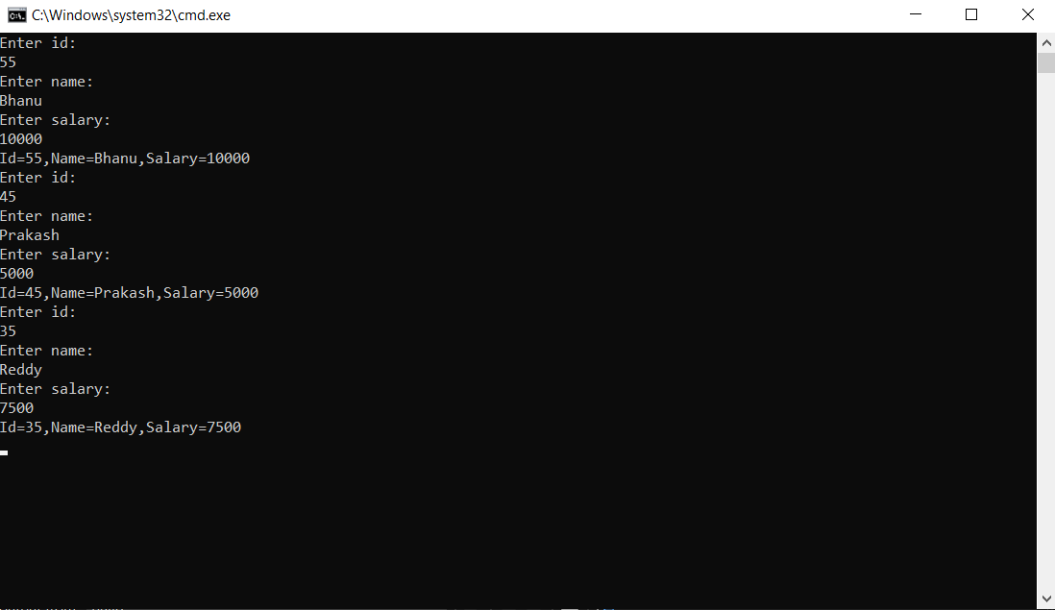

|  |
| --- |
| 2. Write the 3 def of class and 4 points about object discussed in the class? |

**Definitions of Classes**

* Class is a group of variables and methods in which method deals with the variables.
* A class is like a design to create objects.
* A class consists of state and behaviour.

**Four points of Objects**

* An object is an instance of a class.
* We can create any number of objects.
* Objects occupy memory.
* Objects are reference types.

|  |
| --- |
| 3. Pictorially represent class and multiple objects |

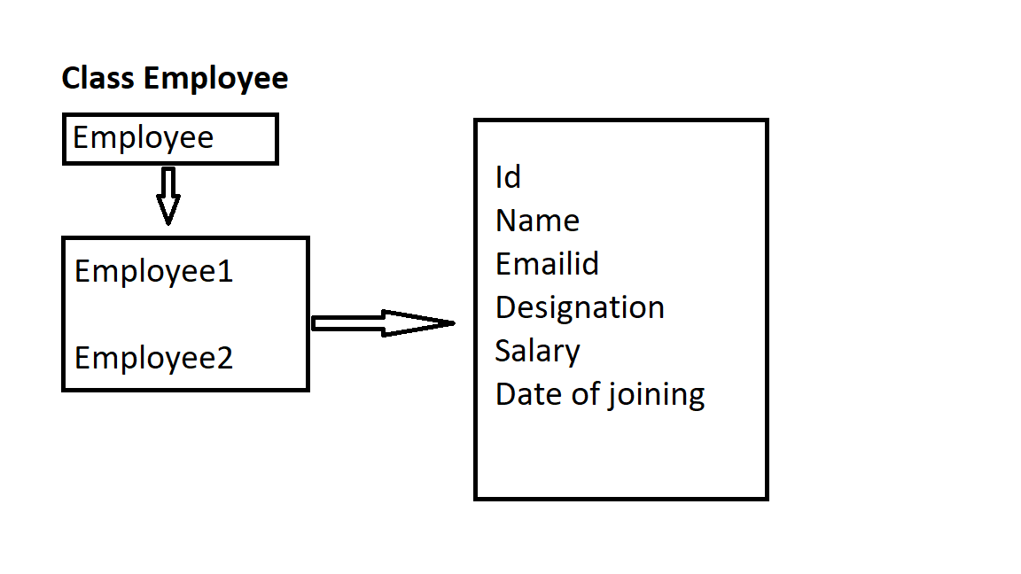

|  |
| --- |
| 4. Create below classes:  1. Customer  2. Product  3. Seller  4. Department |

**Code:**

internal class Customer

{

private int id;

private string name;

private string mobile_number;

public void ReadCustomer()

{

Console.WriteLine("Enter customer id: ");

id = Convert.ToInt32(Console.ReadLine());

Console.WriteLine("Enter customer name: ");

name = (Console.ReadLine());

Console.WriteLine("Enter customer mobile number: ");

mobile_number = (Console.ReadLine());

}

public void PrintCustomer()

{

Console.WriteLine($"Customer Id={id},Customer Name={name}, Customer Mobile Number={mobile_number}");

}

}

internal class Product

{

private int id;

private string name;

private int price;

public void ReadProducts()

{

Console.WriteLine("Enter product id: ");

id = Convert.ToInt32(Console.ReadLine());

Console.WriteLine("Enter product name: ");

name = (Console.ReadLine());

Console.WriteLine("Enter product price: ");

price = Convert.ToInt32(Console.ReadLine());

}

public void PrintProducts()

{

Console.WriteLine($"Product Id={id},Product Name={name},Product Price={price}");

}

}

internal class Seller

{

private string name;

private string emailid;

private string service_number;

public void ReadSeller()

{

Console.WriteLine("Enter seller name: ");

name = (Console.ReadLine());

Console.WriteLine("Enter seller emailid: ");

emailid = (Console.ReadLine());

Console.WriteLine("Enter seller service_number: ");

service_number = (Console.ReadLine());

}

public void PrintSeller()

{

Console.WriteLine($"Seller Name={name},Seller EmailId={emailid},Seller Service_Number={service_number}");

}

}

internal class Department

{

private int dept_id;

private string dept_name;

private int dept_strength;

public void ReadDepartment()

{

Console.WriteLine("Enter dept_id: ");

dept_id = Convert.ToInt32(Console.ReadLine());

Console.WriteLine("Enter dept_name: ");

dept_name = (Console.ReadLine());

Console.WriteLine("Enter dept_strength: ");

dept_strength = Convert.ToInt32(Console.ReadLine());

}

public void PrintDepartment()

{

Console.WriteLine($"Dept_Id={dept_id},Dept_Name={dept_name},Dept_Strength={dept_strength}");

}

}

internal class Program

{

static void Main(string[] args)

{

Customer customer1 = new Customer();

customer1.ReadCustomer();

customer1.PrintCustomer();

Product product1 = new Product();

product1.ReadProducts();

product1.PrintProducts();

Seller seller = new Seller();

seller.ReadSeller();

seller.PrintSeller();

Department department = new Department();

department.ReadDepartment();

department.PrintDepartment();

Console.ReadLine();

}

}

**Output**

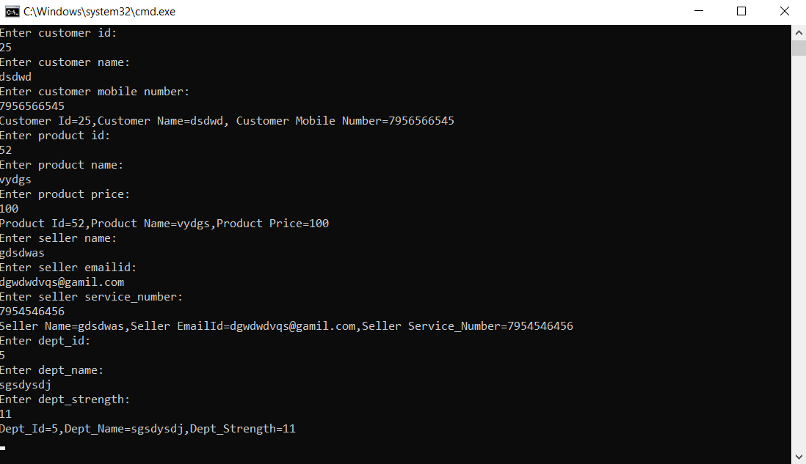

|  |
| --- |
| 5. Create Employee class with 3 public variables.  Create Employee object and initialize with values while creating object and print the values. |

**Code:**

internal class Employee

{

public int id;

public string name;

public int age;

public int salary;

public void ReadEmployee()

{

Console.WriteLine("Enter Id: ");

id = Convert.ToInt32(Console.ReadLine());

Console.WriteLine("Enter Name: ");

name = Console.ReadLine();

Console.WriteLine("Entr Age: ");

age = Convert.ToInt32(Console.ReadLine());

Console.WriteLine("Enter Salary: ");

salary = Convert.ToInt32(Console.ReadLine());

}

public void PrintEmployee()

{

Console.WriteLine($"Id={id},Name={name},Age={age},Salary={salary}");

}

}

internal class Program

{

static void Main(string[] args)

{

Employee employee = new Employee() { id = 1, name = "Bhanu", age = 24, salary = 25356 };

Console.WriteLine($"id={employee.id},name={employee.name},age={employee.age},salary={employee.salary}");

Console.ReadLine();

}

}

**Output:**

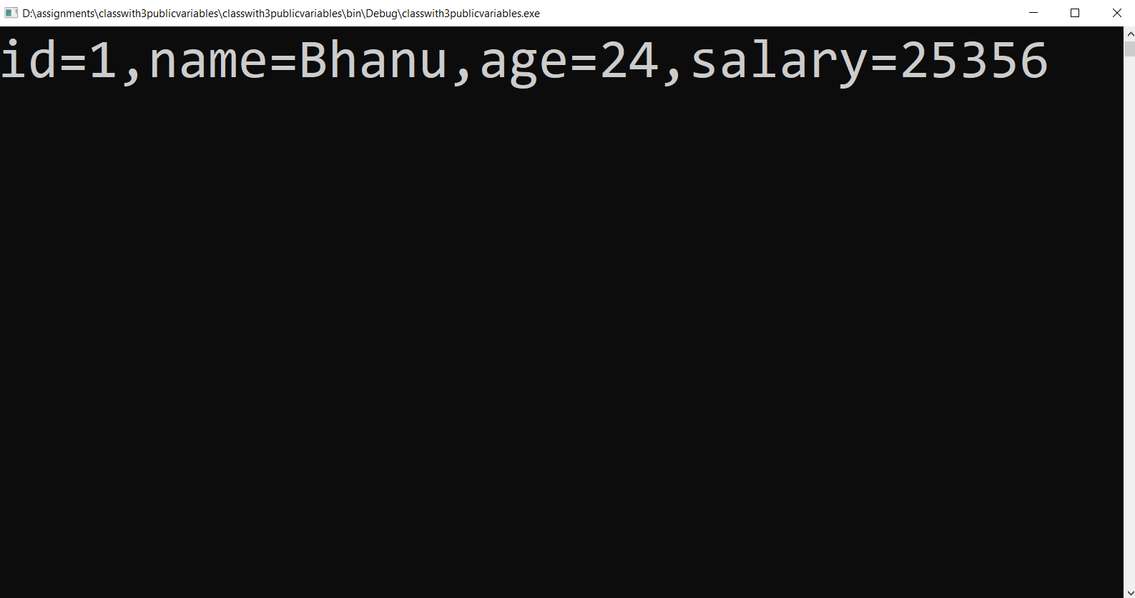

|  |
| --- |
| 6. Create Employee class as shown below:  class Employee  {  public int id;  public string name;  public int salary;  }  now create employees array object and initialize with 5 employees  write code using  a. for loop  b. foreach loop  c. lambda expression. |

**Code:**

internal class Employee

{

public int id;

public string name;

public int salary;

public void ReadEmployee()

{

Console.WriteLine("Enter Id: ");

id = Convert.ToInt32(Console.ReadLine());

Console.WriteLine("Enter Name: ");

name = Console.ReadLine();

Console.WriteLine("Enter Salary: ");

salary = Convert.ToInt32(Console.ReadLine());

}

public void PrintEmployee()

{

Console.WriteLine($"Id={id},Name={name},Salary={salary}");

}

}

internal class Program

{

static void Main(string[] args)

{

Employee[] employee = new Employee[]

{

new Employee(){id=1, name="Bhanu", salary=25356},

new Employee(){id=2, name="Krishna", salary=20000},

new Employee(){id=3, name="RamaKrishna", salary=17500},

new Employee(){id =4, name="Chaitanya", salary=20000},

new Employee(){id=5, name="Suresh", salary=18000}

};

// for loop

for(int i = 0;i< employee.Length;i++)

{

Console.WriteLine($"Id={employee[i].id},Name={employee[i].name},Salary={employee[i].salary}");

}

//foreach loop

foreach(var e in employee)

{

Console.WriteLine($"Id={e.id},Name={e.name},Salary={e.salary}");

}

//lambda Expression

employee.ToList().ForEach(e => Console.WriteLine($"Id={e.id},Name={e.name},Salary={e.salary}"));

Console.ReadLine();

}

}

**Output:**

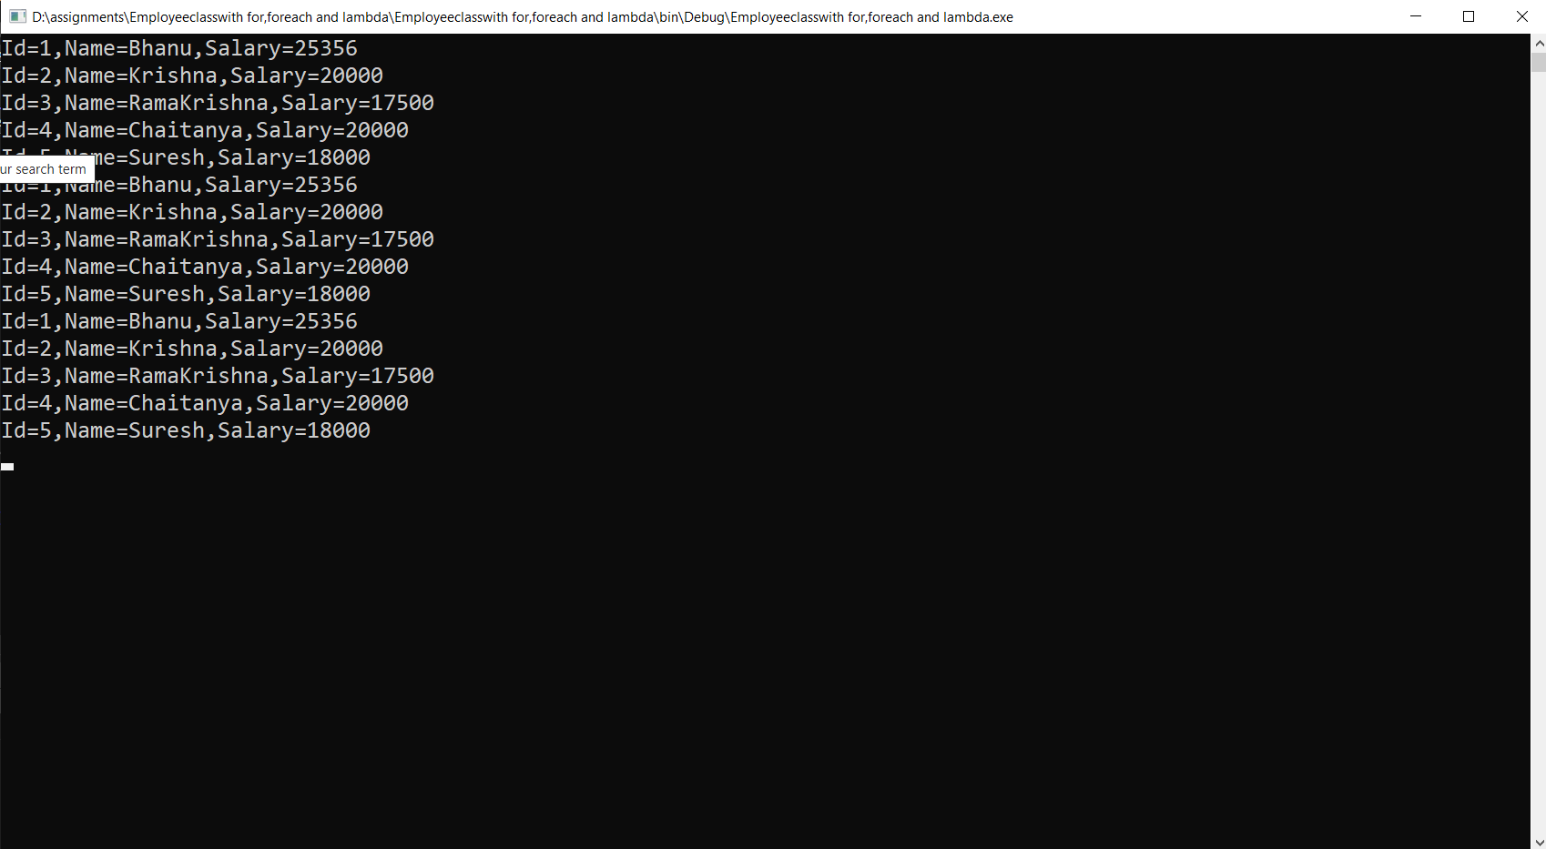

|  |
| --- |
| 7. For the above project,  write code to print employees who is getting salary >=5000 using  for loop  foreach loop  lambda expression |

**Code:**

internal class Employee

{

public int id;

public string name;

public int salary;

public void ReadEmployee()

{

Console.WriteLine("Enter Id: ");

id = Convert.ToInt32(Console.ReadLine());

Console.WriteLine("Enter Name: ");

name = Console.ReadLine();

Console.WriteLine("Enter Salary: ");

salary = Convert.ToInt32(Console.ReadLine());

}

public void PrintEmployee()

{

Console.WriteLine($"Id={id},Name={name},Salary={salary}");

}

}

internal class Program

{

static void Main(string[] args)

{

Employee[] employee = new Employee[]

{

new Employee(){id=1, name="Bhanu", salary=2500},

new Employee(){id=2, name="Krishna", salary=6000},

new Employee(){id=3, name="RamaKrishna", salary=7500},

new Employee(){id =4, name="Chaitanya", salary=2000},

new Employee(){id=5, name="Suresh", salary=8000}

};

// for loop

for (int i = 0; i < employee.Length; i++)

{

if(employee[i].salary >=5000)

Console.WriteLine($"Id={employee[i].id},Name={employee[i].name},Salary={employee[i].salary}");

}

//foreach loop

foreach (var e in employee)

{

if(e.salary >=5000)

Console.WriteLine($"Id={e.id},Name={e.name},Salary={e.salary}");

}

//lambda Expression

employee.ToList().Where(e => e.salary >=5000).ToList().ForEach(e => Console.WriteLine($"Id={e.id},Name={e.name},Salary={e.salary}"));

Console.ReadLine();

}

}

**Output:**

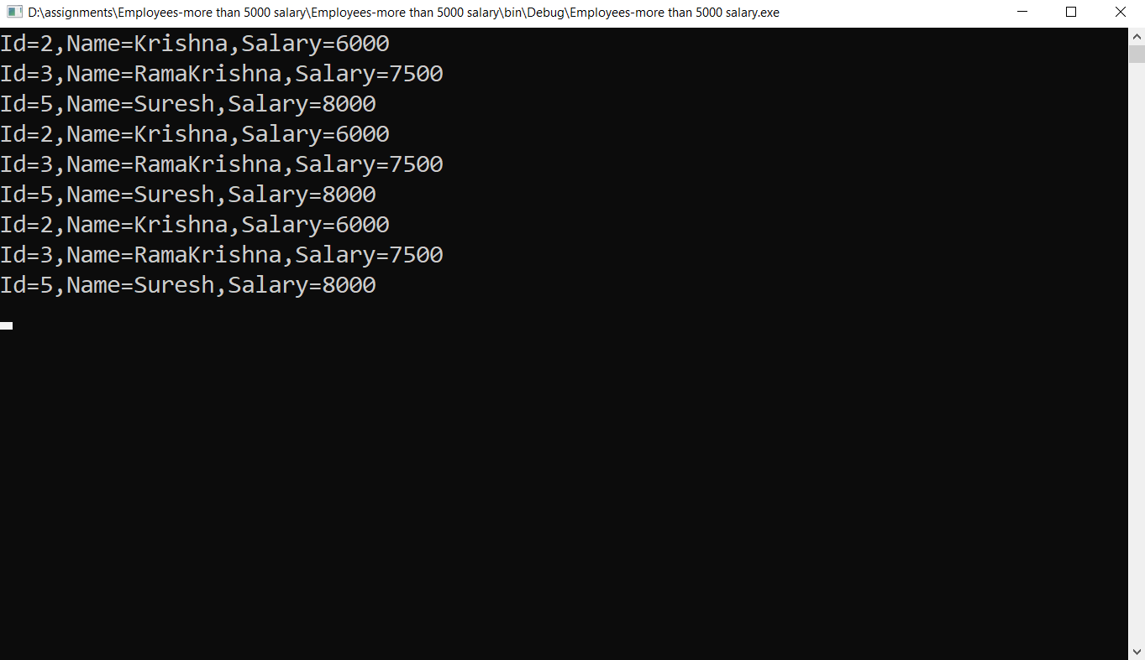

|  |
| --- |
| 8. Similar to 6 and 7 projects create list of Customer and Product Arrays and practice for, foreach and lambda expression |

**Code:**

public int id;

public string name;

public string emailid;

public void ReadCustomer()

{

Console.WriteLine("Enter customer id: ");

id = Convert.ToInt32(Console.ReadLine());

Console.WriteLine("Enter customer name: ");

name = (Console.ReadLine());

Console.WriteLine("Enter customer emailid: ");

emailid= (Console.ReadLine());

}

public void PrintCustomer()

{

Console.WriteLine($"Customer Id={id},Customer Name={name},Customer EmailId={emailid}");

}

}

internal class Product

{

public int id;

public string name;

public int price;

public void ReadProducts()

{

Console.WriteLine("Enter product id: ");

id = Convert.ToInt32(Console.ReadLine());

Console.WriteLine("Enter product name: ");

name = (Console.ReadLine());

Console.WriteLine("Enter product price: ");

price = Convert.ToInt32(Console.ReadLine());

}

public void PrintProducts()

{

Console.WriteLine($"Product Id={id},Product Name={name},Product Price={price}");

}

}

internal class Program

{

static void Main(string[] args)

{

Customer[] customer = new Customer[]

{

new Customer(){id=1, name="Bhanu", emailid="abc@gmail.com"},

new Customer(){id=2, name="Krishna", emailid="cde@gmail.com"},

new Customer(){id=3, name="RamaKrishna", emailid="def@gmail.com"},

new Customer(){id=4, name="Chaitanya", emailid="fgh@gmail.com"},

new Customer(){id=5, name="Suresh", emailid="ghi@gmail.com"}

};

Product[] product = new Product[]

{

new Product(){id=1, name="Tin", price=800},

new Product(){id=2, name="Coke", price=700},

new Product(){id=3, name="Sprite", price=400},

new Product(){id=4, name="Plugbox", price=850},

new Product(){id=5, name="Lays", price=900}

};

// for loop

for (int i = 0; i < customer.Length; i++)

{

Console.WriteLine($"Id={customer[i].id},Name={customer[i].name},Emailid={customer[i].emailid}");

}

for (int i = 0; i < product.Length; i++)

{

Console.WriteLine($"Id={product[i].id},Name={product[i].name},price={product[i].price}");

}

//foreach loop

foreach (var c in customer)

{

Console.WriteLine($"Id={c.id},Name={c.name},Emailid={c.emailid}");

}

foreach (var p in product)

{

Console.WriteLine($"Id={p.id},Name={p.name},Price={p.price}");

}

//lambda Expression

customer.ToList().ForEach(c => Console.WriteLine($"Id={c.id},Name={c.name},Salary={c.emailid}"));

product.ToList().ForEach(p => Console.WriteLine($"Id={p.id},Name={p.name},Salary={p.price}"));

Console.ReadLine()

}

}

**Output:**

